Nondestructive Ultrasonic Evaluation of Electrofusion Joints of thermoplastic piping for Gas distribution

1. Scope
This practice describes the inspection of Electrofusion (EF) joints of thermoplastic pipes for gas distribution by the use of nondestructive ultrasonic imaging equipment.

2. Summary

  - This practice consists of using sound waves to inspect Electrofusion (EF) joints of heat-fused thermoplastic pipes and displaying on a visual monitor any evidence of voids, cracks, discontinuities, bad fusion interfaces, dislocations of heating wires etc., in the joints. In this manner, the joints can be field-tested nondestructively as an aid in judging the quality of these joints.

  - This practice recommends a technique whereby the presence of voids, cracks, discontinuities, bad fusion interfaces, dislocations of heating wires etc., in the heat fusion joints can be identified.

  - Ultrasonic testing can be done in the field in a minimum amount of time. It does not cause significant construction delay, while still providing an aid to quality control before burial of the pipe.

- Apparatus

  - Ultrasonic tester – An electronic instrument which not only generates and receives electronic signals but also makes real time ultrasound images.

  - Transducer – Ultrasound array transducer converts the electrical energy to sound and back to electrical energy.

Table 1 Type of Transducers
Frequency (MHz) | Recommended Coupler Thickness (mm)
3.5 | Over 20
5.0 | 6~25
7.5 | Up to 15
  - Display – Two dimensional ultrasound brightness images of the cross section of the test specimen are displayed in real time. The horizontal scale indicates the relative horizontal position of the image area of the test specimen. The vertical scale indicates the relative depth of the image area of the test specimen from the face of the transducer. The reflected sound is indicated in two dimensional image as brightness. These indicate the locations, sizes, angles, and types of acoustic discontinuities.

  - Couplant – A film of lubricant between the transducer and the test specimen acts as a couplant, and allows the transducer to send ultrasound to the test specimen.

  - Calibration block – In order to set up the scanning sensitivity, the calibration block is required. Calibration block should be made of the same or acoustically equivalent material being inspected and it should have 5 side-drilled holes in accordance with depth (See Fig. 1).

- Typical procedure

  - Sensitivity setting

    - Calibration block - Choose the side drilled holes whose depth (hole to surface) is close with the thickness of coupler to be inspected. Then put the transducer on the block surface and adjust gain to get the image that has the resolution and sensitivity to identify each side-drilled hole (See Fig. 2).

    - Alternative method - Put the transducer on outer surface of an acceptable EF joint of which thickness is the same as the test specimen. Then, adjust gain to get the image that has the resolution and sensitivity to identify wires individually (See Fig. 3 and 4).

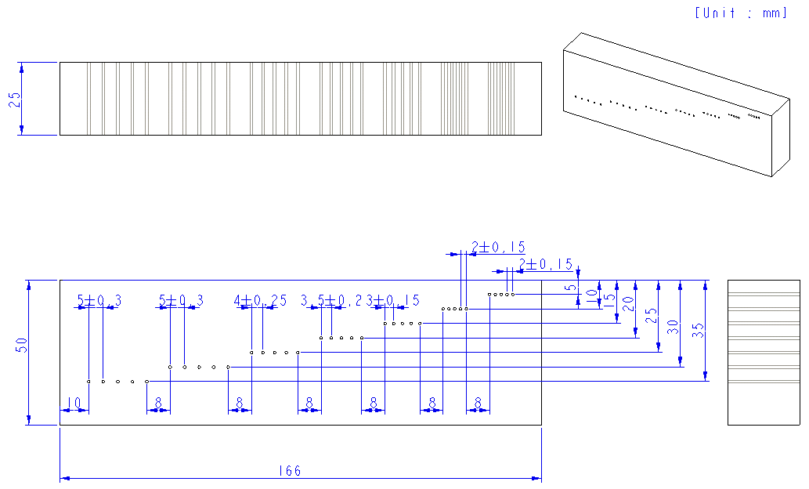
General comments
- Holes shall be drilled and reamed, and essentially parallel to inspection surface.
- Length, height, width, space between hole layers and distances between hole layers and edges, are minimum values.
- Hole diameter : 1 ± 0.15(mm)
Fig. 1 Calibration block

Fig. 2 Standard sensitivity setting - Sample image obtained from calibration block

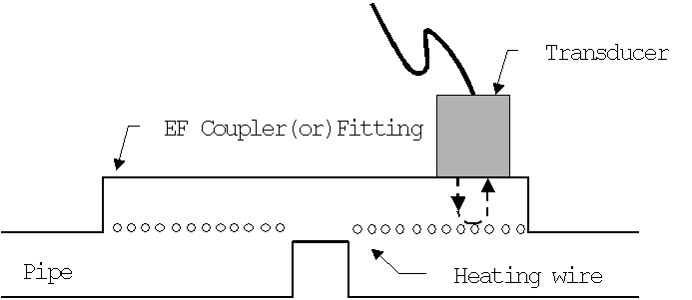

Fig. 3 Alternative calibration method

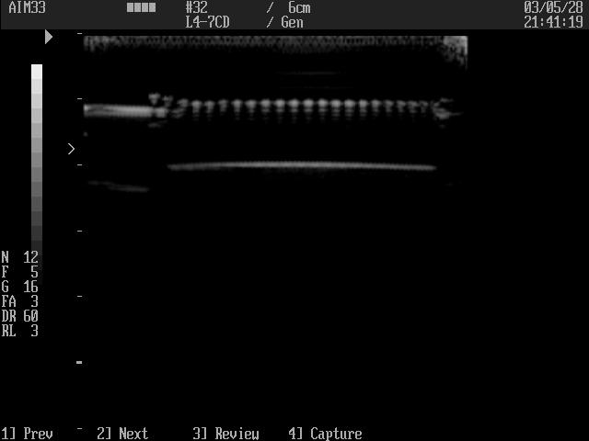

Fig. 4 Alternative sensitivity setting - Sample image obtained from

the acceptable EF joint

  - Inspection procedure

    - The inspection surface shall be free of contamination.
    - Set up the ultrasonic tester and use proper transducer that is recommended in accordance with the thickness of coupler (See table 1).
    - Apply couplant to the calibration block and adjust the sensitivity according to the paragraph 4.1. The tester is now calibrated.

    - Apply the couplant to the joint to be inspected. Select four inspection points separating about 90 degrees each other(See Fig 5). Observe the display whether there are any recordable indications. Move the transducer circumferentially in the path as wide the transducer to inspect the entire joint, if any recordable indications are detected.

Note) The recordable indications are those caused by voids, cracks, bad fusion interfaces, dislocations of heating wires, excluding by intrinsic geometry such as wires, cold zone interfaces, and inner surface of the pipe. The indication at the edge of fusion zone should not be considered as recordable indications, if the indication does not penetrate beyond the second wire position from the each edge of fusion zone.

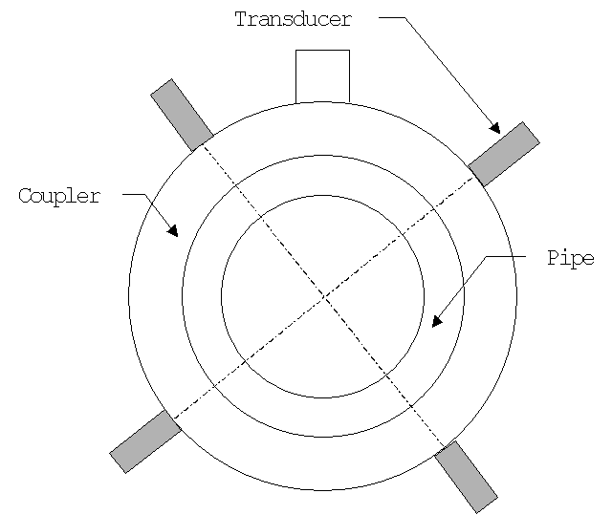

Fig5. Four inspection points on the circumference of EF joint

- Acceptance criteria

- Evaluations of the indication
  - The joint is not accepted if there is an indication that exceeds 10% of the fusion zone length.
  - The joint is not accepted if there are multiple indications¹⁾ of which the combined size exceeds 20% of the fusion zone length.
- Evaluations for the dislocation of heating wires – The joint is not accepted if the locations of the heating wires are different from the expected locations. In general, the dislocation of heating wire is caused by the excessive heating time or temperature.

Note
  - When two indications are close together, if the distance between two successive indications exceeds 2L where L is the length of the longer one, these indications shall be considered independently each other. Otherwise they shall be considered single indication including distance between indications.
  - Client may establish the acceptance criteria considering design factor such as pressure, type of coupler, welding condition and so on.

Report

Following things shall be included in the report.

- Report number
- Inspector name
- Inspection date
- Model and serial numbers of ultrasonic tester
- Model, serial number and frequency of transducer
- Equipment setting up such as gain, rejection level, dynamic range, frame average and so on
- Client drawing or part number of EF coupler
- Purchase order number or manufacturer’s serial number if necessary
- Inspection sketch including the position of the recordable indication
- Minimum 4 points images (each point per 90 degree)
- If any unacceptable indications are detected, some images which have largest indication and/or which may represent the defective area.

Appendix I - Interpretation Guide

1. Good EF Joint
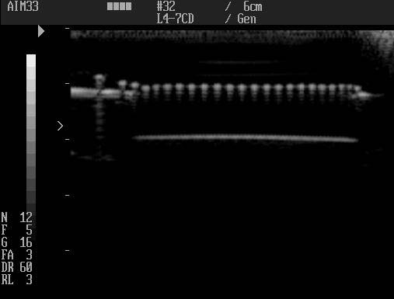

Ultrasonic image shows clear wire indications. White points represent heating wires along the fusion interface.

2. Bad fusion interface
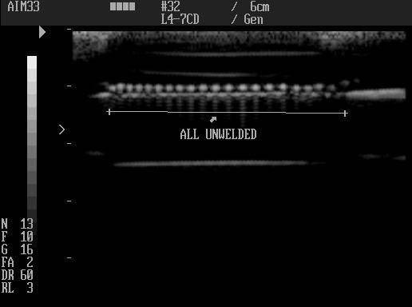

The white linear line, which is located underneath of wire indications, indicates bad fusion interface.

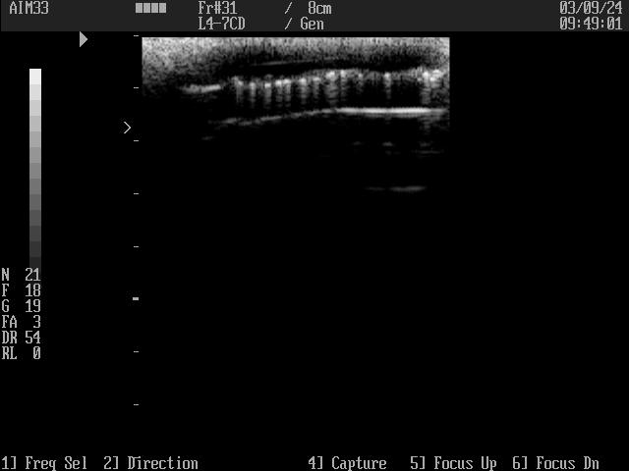
3. Dislocation of heating wires

Ultrasonic image shows the dislocation of heating wires due to overheating.
4. Voids
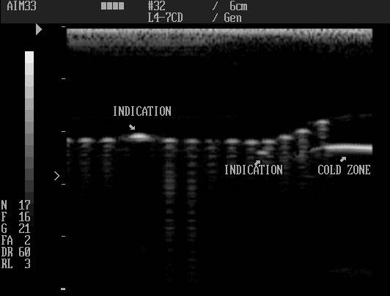
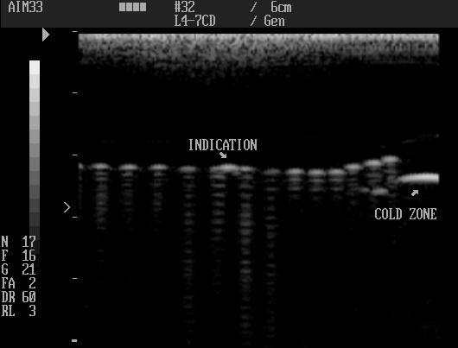

If indication is located just above or almost at the wires, it is a void.

5. Void on coupler

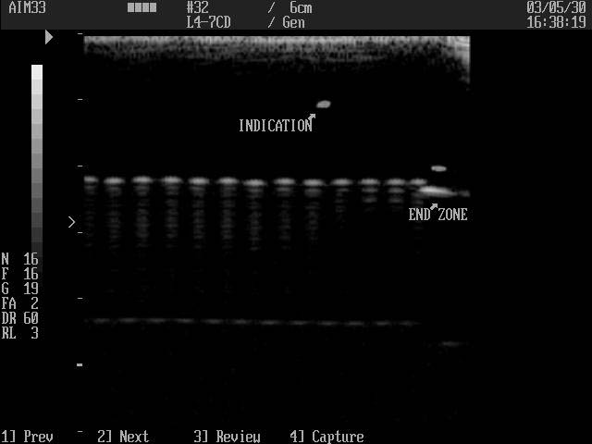

This type of void is not related with electrofusion joining because it is located far above heating wire line.

6. Edge indications

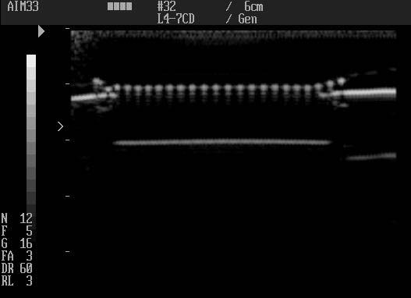

In general, EF joints are not perfect at both edges. Therefore, they shall not be included in recordable indication.

